Case study-1

Complete 3-5 questions and wrin

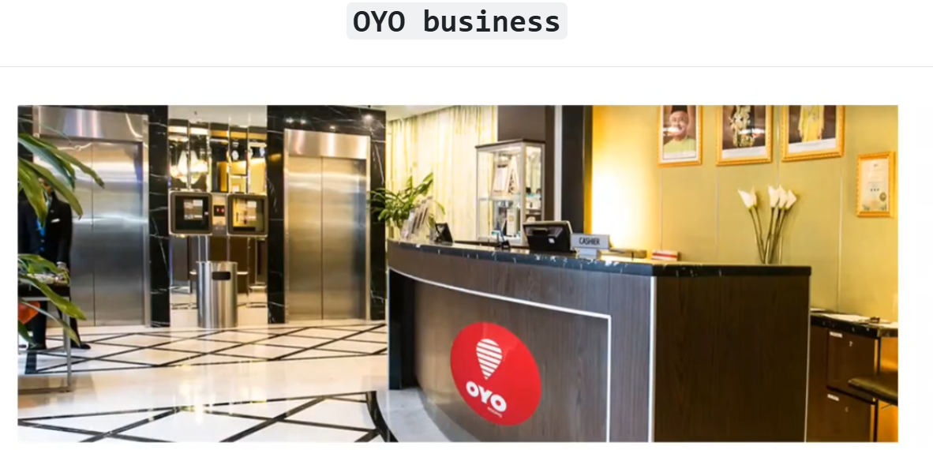

Apply various SQL functions such as :  
✅ CTE  
✅ Joins  
✅ Logical Operator  
✅ Group by, Order by, Where  
✅ Aggregate functions Sum, Count, Average  
✅ Date functions Datename, Datediff, Month

Database Used - Microsoft SQL Server  
Insights:-

1. Banglore , gurgaon & delhi were popular in the bookings, whereas Kolkata is less popular in bookings
2. Nature of Bookings:

• Nearly 50 % of the bookings were made on the day of check in only.  
• Nearly 85 % of the bookings were made with less than 4 days prior to the date of check in.  
• Very few no.of bookings were made in advance(i.e over a 1 month or 2 months).  
• Most of the bookings involved only a single room.  
• Nearly 80% of the bookings involved a stay of 1 night only.

1. Oyo should acquire more hotels in the cities of Pune, Kolkata & Mumbai. Because their average room rates are comparetively higher so more revenue will come.
2. The % cancellation Rate is high on all 9 cities except pune , so Oyo should focus on finding reasons about cancellation.

Outputs:

Find the - average room rates of different cities

Find the - No of bookings of different cities in Jan Feb Mar Months.

Write a sql query for the -- Frequency of early bookings prior to check-in the hotel

write the sql query Frequency of bookings of no of rooms in Hotel

write the sql query-- NEW CUSTOMERS ON JAN MONTH

Write a sql query Net revenue to company (due to some bookings cancelled)

Write a sql query for Gross revenue to company

write a sql query for -- average room rates of different cities